Cancer Analysis

This project is to do statistic and machine learning analyse. There are five .py files. **<CA_Lib>**

**import** pandas **as** pd  
**import** matplotlib.pyplot **as** plt  
**from** sklearn.model_selection **import** train_test_split  
**from** sklearn.linear_model **import** LogisticRegression  
**from** sklearn.metrics **import** accuracy_score  
**import** numpy **as** np  
**from** sklearn.preprocessing **import** StandardScaler  
**from** sklearn.linear_model **import** Perceptron  
**from** sklearn.svm **import** SVC  
**from** sklearn.tree **import** DecisionTreeClassifier  
**from** pandas **import** DataFrame, Series  
**from** sklearn.ensemble **import** RandomForestClassifier  
**from** sklearn.neighbors **import** KNeighborsClassifier  
**from** sklearn.decomposition **import** PCA  
**from** sklearn.discriminant_analysis **import** LinearDiscriminantAnalysis  
**from** sklearn.decomposition **import** KernelPCA  
**from** sklearn.preprocessing **import** LabelEncoder  
**from** sklearn.pipeline **import** Pipeline  
**from** sklearn.model_selection **import** learning_curve  
**from** sklearn.model_selection **import** validation_curve  
**from** sklearn.model_selection **import** GridSearchCV  
**import** seaborn **as** sns  
  
columns **= ['radius_mean'**, **'texture_mean'**, **'perimeter_mean'**,  
 **'area_mean'**, **'smoothness_mean'**, **'compactness_mean'**,  
 **'concavity_mean'**, **'concave points_mean'**, **'symmetry_mean'**,  
 **'fractal_dimension_mean']**

**<CancerAnalysis>**

**"""  
This is to do something about the cancer data.  
The data comes from Kaggle.  
We try to find some relationships inside the data, and  
build a predictive model, if possible.  
  
Statistic Analysis: plotting data distribution.  
Machine Learning Analysis:  
1, Training each classifier  
2, observe the accuracy of each classifier with the parameter varying  
3, plotting Learning curve and validation curve  
4, grid search optimization  
  
"""  
  
from** CA_Lib **import *  
from** StatisticalAnalysis **import** statistic_analysis  
**from** MLAnalysis **import** ml_analysis  
  
  
**def run():** print**('Loading Data >>> ......')** filename **= 'dataSet/cancer.csv'** df **=** pd.read_csv**(**filename**)** X **=** df**[**columns**]** y **=** df**['diagnosis']** print**('Finished!')** print**('Starting Statistic Analysis >>> ......')** statistic_analysis**(**X, y**)** print**('Finished!')** print**('Starting Machine Learning Analysis >>> ......')** ml_analysis**(**X, y**)** print**('Finished!')  
  
  
def app():** run**()  
  
  
if** __name__ **== '__main__':** app**()**

**<Feature_Selection>**

**from** sklearn.base **import** clone  
**from** itertools **import** combinations  
**import** numpy **as** np  
**from** sklearn.model_selection **import** train_test_split  
**from** sklearn.metrics **import** accuracy_score  
  
  
**class SBS(**object**):  
 def __init__(**self, estimator, k_features,  
 scoring**=**accuracy_score,  
 test_size**=**0.25, random_state**=**1**):** self.scoring **=** scoring  
 self.estimator **=** clone**(**estimator**)** self.k_features **=** k_features  
 self.test_size **=** test_size  
 self.random_state **=** random_state  
  
 **def fit(**self, X, y**):** X_train, X_test, y_train, y_test **=** \  
 train_test_split**(**X, y, test_size**=**self.test_size,  
 random_state**=**self.random_state**)** dim **=** X_train.shape**[**1**]** self.indices_ **=** tuple**(**range**(**dim**))** self.subsets_ **= [**self.indices_**]** score **=** self._calc_score**(**X_train, y_train,  
 X_test, y_test, self.indices_**)** self.scores_ **= [**score**]  
 while** dim **>** self.k_features**:** scores **= []** subsets **= []  
  
 for** p **in** combinations**(**self.indices_, r**=**dim**-**1**):** score **=** self._calc_score**(**X_train, y_train,  
 X_test, y_test, p**)** scores.append**(**score**)** subsets.append**(**p**)** best **=** np.argmax**(**scores**)** self.indices_ **=** subsets**[**best**]** self.subsets_.append**(**self.indices_**)** dim **-=** 1  
 self.scores_.append**(**scores**[**best**])** self.k_score_ **=** self.scores_**[-**1**]  
  
 return** self  
  
 **def transform(**self, X**):  
 return** X**[:**, self.indices_**]  
  
 def _calc_score(**self, X_train, y_train,  
 X_test, y_test, indices**):** self.estimator.fit**(**X_train**[:**, indices**]**, y_train**)** y_pred **=** self.estimator.predict**(**X_test**[:**, indices**])** score **=** self.scoring**(**y_test, y_pred**)  
  
 return** score

**<MLAnalysis>**

**from** CA_Lib **import *  
from** Feature_Selection **import** SBS  
  
  
**def dimensionality_reduction(**x_train, x_test, y_train, option**):** x_train_, x_test_ **=** 0.0, 0.0  
  
 **if** option **== 'PCA':** pca **=** PCA**(**n_components**=**7**)** x_train_ **=** pca.fit_transform**(**x_train**)** x_test_ **=** pca.transform**(**x_test**)  
  
 elif** option **== 'KernelPCA':** pca **=** PCA**(**n_components**=**7**)** x_train_ **=** pca.fit_transform**(**x_train**)** x_test_ **=** pca.transform**(**x_test**)  
  
 elif** option **== 'LDA':** lda **=** LinearDiscriminantAnalysis**(**n_components**=**8**)** x_train_ **=** lda.fit_transform**(**x_train, y_train**)** x_test_ **=** lda.transform**(**x_test**)  
  
 return** x_train_, x_test_  
  
  
**def standardize_data(**x_train, x_test**):** sc **=** StandardScaler**()** x_train_std_ **=** sc.fit_transform**(**x_train**)** x_test_std_ **=** sc.transform**(**x_test**)  
  
 return** x_train_std_, x_test_std_  
  
  
**def calculate_accuracy(**x_train, x_test, y_train, y_test, clf**):** clf.fit**(**x_train, y_train**)** y_pred **=** clf.predict**(**x_test**)** accuracy_ **=** accuracy_score**(**y_test, y_pred**)  
  
 return** accuracy_  
  
  
**def train(**x_train_std, x_test_std, y_train, y_test**):** param_ **= {}** accuracy_ **= {}** acc **= []** para **= []  
  
 for** eta **in** np.arange**(**0.000001, 0.4, 0.005**):** ppn **=** Perceptron**(**max_iter**=**300, eta0**=**eta, tol**=**1e-5, random_state**=**0**)** acc.append**(**calculate_accuracy**(**x_train_std, x_test_std, y_train, y_test, ppn**))** para.append**(**eta**)** # acc.append(max(acc))  
 # para.append(para[acc.index(max(acc))])  
 param_**['eta'] =** para  
 accuracy_**['Perceptron'] =** acc  
  
 acc **= []** para **= []  
 for** c **in** range**(-**5, 5**):** C **=** 10**\*\*(**c**)** lr **=** LogisticRegression**(**C**=**C, random_state**=**0, solver**='lbfgs')** acc.append**(**calculate_accuracy**(**x_train_std, x_test_std, y_train, y_test, lr**))** para.append**(**c**)** # acc.append(max(acc))  
 # para.append(para[acc.index(max(acc))])  
 param_**['C_LR'] =** para  
 accuracy_**['Logistic_Regression'] =** acc  
  
 acc **= []** para **= []  
 for** c **in** range**(-**5, 5**):** C **=** 10**\*\*(**c**)** svm **=** SVC**(**kernel**='linear'**, C**=**C, random_state**=**0**)** acc.append**(**calculate_accuracy**(**x_train_std, x_test_std, y_train, y_test, svm**))** para.append**(**c**)** # acc.append(max(acc))  
 # para.append(para[acc.index(max(acc))])  
 param_**['C_SVMLin'] =** para  
 accuracy_**['SVM_Linear'] =** acc  
  
 acc **= []** para **= []  
 for** c **in** range**(-**5, 5**):** C **=** 10**\*\*(**c**)** svm **=** SVC**(**kernel**='rbf'**, random_state**=**0, gamma**=**0.05, C**=**C**)** acc.append**(**calculate_accuracy**(**x_train_std, x_test_std, y_train, y_test, svm**))** para.append**(**c**)** # acc.append(max(acc))  
 # para.append(para[acc.index(max(acc))])  
 param_**['C_SVMrbf'] =** para  
 accuracy_**['SVM_RBF'] =** acc  
  
 acc **= []** para **= []  
 for** c **in** range**(**1, 10**):** tree **=** DecisionTreeClassifier**(**criterion**='entropy'**, max_depth**=**c, random_state**=**0**)** acc.append**(**calculate_accuracy**(**x_train_std, x_test_std, y_train, y_test, tree**))** para.append**(**c**)** # acc.append(max(acc))  
 # para.append(para[acc.index(max(acc))])  
 param_**['maxdepth'] =** para  
 accuracy_**['Decision_Tree'] =** acc  
  
 acc **= []** para **= []  
  
 for** c **in** range**(**10, 200, 10**):** RF **=** RandomForestClassifier**(**criterion**='entropy'**, n_estimators**=**c, random_state**=**0**)** acc.append**(**calculate_accuracy**(**x_train_std, x_test_std, y_train, y_test, RF**))** para.append**(**c**)** # acc.append(max(acc))  
 # para.append(para[acc.index(max(acc))])  
 param_**['n_estimator'] =** para  
 accuracy_**['Random_Forest'] =** acc  
  
 acc **= []** para **= []  
  
 for** c **in** range**(**1, 20**):** KNN **=** KNeighborsClassifier**(**n_neighbors**=**c, p**=**2, metric**='minkowski')** acc.append**(**calculate_accuracy**(**x_train_std, x_test_std, y_train, y_test, KNN**))** para.append**(**c**)** # acc.append(max(acc))  
 # para.append(para[acc.index(max(acc))])  
 param_**['n_neighbor'] =** para  
 accuracy_**['KNN'] =** acc  
  
 **return** param_, accuracy_  
  
  
**def param_accuracy_plot(**param, accuracy**):** fig **=** plt.figure**()** ith_fig **=** 0  
  
 **for** key1, key2 **in** zip**(**param, accuracy**):** ith_fig **+=** 1  
 ax **=** fig.add_subplot**(**3, 4, ith_fig**)** ax.plot**(**param**[**key1**]**, accuracy**[**key2**])** plt.title**(**key2**)** plt.xlabel**(**key1**)** plt.ylabel**('accuracy')** # plt.draw()  
 # plt.pause(0.5)  
  
 plt.subplots_adjust**(**wspace**=**0.5, hspace**=**0.5**)** plt.show**()  
  
  
def sequential_feature_selection(**x_train_std, y_train, param**):** ppn **=** Perceptron**(**max_iter**=**300, eta0**=**0.01, tol**=**1e-5, random_state**=**0**)** lr **=** LogisticRegression**(**C**=**1, random_state**=**0, solver**='lbfgs')** svm_lin **=** SVC**(**kernel**='linear'**, C**=**10, random_state**=**0**)** svm_rbf **=** SVC**(**kernel**='rbf'**, random_state**=**0, gamma**=**0.05, C**=**10**)** tree **=** DecisionTreeClassifier**(**criterion**='entropy'**, max_depth**=**3, random_state**=**0**)** rf **=** RandomForestClassifier**(**criterion**='entropy'**, n_estimators**=**10, random_state**=**0**)** knn **=** KNeighborsClassifier**(**n_neighbors**=**4, p**=**2, metric**='minkowski')** clfs **= [**ppn, lr, svm_lin, svm_rbf, tree, rf, knn**]** names **= ['Perceptron'**, **'Logistic Regression'**, **'SVM_Linear'**, **'SVM_rbf'**, **'Decision Tree'**, **'Random Forest'**, **'KNN']  
  
 for** clf **in** clfs**:** sbs **=** SBS**(**clf, k_features**=**1**)** sbs.fit**(**x_train_std, y_train**)** k_feat **= [**len**(**k**) for** k **in** sbs.subsets_**]** plt.plot**(**k_feat, sbs.scores_, marker**='o')** plt.ylabel**('Accuracy')** plt.xlabel**('Number of features')** # plt.draw()  
 # plt.pause(0.5)  
  
 plt.legend**(**names**)** plt.show**()  
  
  
def feature_importance(**x_train, y_train**):** feat_labels **=** columns  
 forest **=** RandomForestClassifier**(**n_estimators**=**10000, random_state**=**0, n_jobs**=-**1**)** forest.fit**(**x_train, y_train**)** importances **=** forest.feature_importances_  
 indices **=** np.argsort**(**importances**)[::-**1**]  
 for** f **in** range**(**x_train.shape**[**1**]):** print**("%2d) %-*s %f" % (**f **+** 1, 30,  
 feat_labels**[**indices**[**f**]]**,  
 importances**[**indices**[**f**]]))  
  
  
def classifier_learning_curve(**x_train, y_train**):** pipe_ppn **=** Pipeline**([('sc'**, StandardScaler**())**,  
 **('clf'**, Perceptron**(**max_iter**=**300, eta0**=**0.01, tol**=**1e-5, random_state**=**0**))])** pipe_lr **=** Pipeline**([('sc'**, StandardScaler**())**,  
 **('clf'**, LogisticRegression**(**penalty**='l2'**, random_state**=**0, solver**='lbfgs'))])** pipe_svm_lin **=** Pipeline**([('sc'**, StandardScaler**())**,  
 **('clf'**, SVC**(**kernel**='linear'**, C**=**10, random_state**=**0**))])** pipe_svm_rbf **=** Pipeline**([('sc'**, StandardScaler**())**,  
 **('clf'**, SVC**(**kernel**='rbf'**, random_state**=**0, gamma**=**0.05, C**=**10**))])** pipe_tree **=** Pipeline**([('sc'**, StandardScaler**())**,  
 **('clf'**, DecisionTreeClassifier**(**criterion**='entropy'**, max_depth**=**3, random_state**=**0**))])** pipe_rf **=** Pipeline**([('sc'**, StandardScaler**())**,  
 **('clf'**, RandomForestClassifier**(**criterion**='entropy'**, n_estimators**=**20, random_state**=**0**))])** pipe_knn **=** Pipeline**([('sc'**, StandardScaler**())**,  
 **('clf'**, KNeighborsClassifier**(**n_neighbors**=**4, p**=**2, metric**='minkowski'))])** clfs **= [**pipe_ppn, pipe_lr, pipe_svm_lin, pipe_svm_rbf, pipe_tree, pipe_rf, pipe_knn**]** names **= ['Perceptron'**, **'Logistic Regression'**, **'SVM_Linear'**, **'SVM_rbf'**, **'Decision Tree'**, **'Random Forest'**, **'KNN']** fig **=** plt.figure**()** ith_fig **=** 0  
  
 **for** name, clf **in** zip**(**names, clfs**):** ith_fig **+=** 1  
 ax **=** fig.add_subplot**(**3, 4, ith_fig**)** learning_curve_plot**(**x_train, y_train, clf, name**)** plt.subplots_adjust**(**wspace**=**0.5, hspace**=**0.5**)** plt.show**()  
  
  
def learning_curve_plot(**x_train, y_train, clf, title**):** train_sizes, train_scores, test_scores **=** learning_curve**(**estimator**=**clf,  
 X**=**x_train, y**=**y_train,  
 train_sizes**=**np.linspace**(**0.1, 1.0, 10**)**,  
 cv**=**10, n_jobs**=-**1**)** train_mean **=** np.mean**(**train_scores, axis**=**1**)** train_std **=** np.std**(**train_scores, axis**=**1**)** test_mean **=** np.mean**(**test_scores, axis**=**1**)** test_std **=** np.std**(**test_scores, axis**=**1**)** plt.plot**(**train_sizes, train_mean,  
 color**='blue'**, marker**='o'**,  
 markersize**=**5, label**='training accuracy')** plt.fill_between**(**train_sizes,  
 train_mean **+** train_std,  
 train_mean **-** train_std,  
 alpha**=**0.15, color**='blue')** plt.plot**(**train_sizes, test_mean,  
 color**='green'**, linestyle**='--'**,  
 marker**='s'**, markersize**=**5,  
 label**='validation accuracy')** plt.fill_between**(**train_sizes,  
 test_mean **+** test_std,  
 test_mean **-** test_std,  
 alpha**=**0.15, color**='green')** plt.grid**()** plt.title**(**title**)** plt.xlabel**('Number of training samples')** plt.ylabel**('Accuracy')** plt.legend**()** plt.ylim**([**0.4, 1.0**])  
  
  
def classifier_validation_curve(**x_train, y_train**):** pipe_ppn **=** Pipeline**([('sc'**, StandardScaler**())**,  
 **('clf'**, Perceptron**(**max_iter**=**300, eta0**=**0.01, tol**=**1e-5, random_state**=**0**))])** pipe_lr **=** Pipeline**([('sc'**, StandardScaler**())**,  
 **('clf'**, LogisticRegression**(**penalty**='l2'**, random_state**=**0, solver**='lbfgs'))])** pipe_svm_lin **=** Pipeline**([('sc'**, StandardScaler**())**,  
 **('clf'**, SVC**(**kernel**='linear'**, C**=**10, random_state**=**0**))])** pipe_svm_rbf **=** Pipeline**([('sc'**, StandardScaler**())**,  
 **('clf'**, SVC**(**kernel**='rbf'**, random_state**=**0, gamma**=**0.05, C**=**10**))])** pipe_tree **=** Pipeline**([('sc'**, StandardScaler**())**,  
 **('clf'**, DecisionTreeClassifier**(**criterion**='entropy'**, max_depth**=**3, random_state**=**0**))])** pipe_rf **=** Pipeline**([('sc'**, StandardScaler**())**,  
 **('clf'**, RandomForestClassifier**(**criterion**='entropy'**, n_estimators**=**20, random_state**=**0**))])** pipe_knn **=** Pipeline**([('sc'**, StandardScaler**())**,  
 **('clf'**, KNeighborsClassifier**(**n_neighbors**=**4, p**=**2, metric**='minkowski'))])** clfs **= [**pipe_lr, pipe_svm_lin, pipe_svm_rbf**]** names **= ['Logistic Regression'**, **'SVM_Linear'**, **'SVM_rbf']** fig **=** plt.figure**()** ith_fig **=** 0  
  
 **for** name, clf **in** zip**(**names, clfs**):** ith_fig **+=** 1  
 ax **=** fig.add_subplot**(**1, 3, ith_fig**)** validation_curve_plot**(**x_train, y_train, clf, name**)** plt.subplots_adjust**(**wspace**=**0.5, hspace**=**0.5**)** plt.show**()  
  
  
def validation_curve_plot(**x_train, y_train, clf, title**):** param_range **= [**0.001, 0.01, 0.1, 1.0, 10.0, 100.0**]** train_scores, test_scores **=** validation_curve**(**estimator**=**clf,  
 X**=**x_train, y**=**y_train,  
 param_name**='clf__C'**,  
 param_range**=**param_range,  
 cv**=**10**)** train_mean **=** np.mean**(**train_scores, axis**=**1**)** train_std **=** np.std**(**train_scores, axis**=**1**)** test_mean **=** np.mean**(**test_scores, axis**=**1**)** test_std **=** np.std**(**test_scores, axis**=**1**)** plt.plot**(**param_range, train_mean,  
 color**='blue'**, marker**='o'**,  
 markersize**=**5,  
 label**='training accuracy')** plt.fill_between**(**param_range, train_mean **+** train_std,  
 train_mean **-** train_std, alpha**=**0.15,  
 color**='blue')** plt.plot**(**param_range, test_mean,  
 color**='green'**, linestyle**='--'**,  
 marker**='s'**, markersize**=**5,  
 label**='validation accuracy')** plt.fill_between**(**param_range,  
 test_mean **+** test_std,  
 test_mean **-** test_std,  
 alpha**=**0.15, color**='green')** plt.grid**()** plt.xscale**('log')** plt.legend**(**loc**='lower right')** plt.xlabel**('Parameter C')** plt.ylabel**('Accuracy')** plt.title**(**title**)** plt.ylim**([**0.4, 1.0**])  
  
  
def grid_search_optimization(**x_train, y_train**):** pipe_svc **=** Pipeline**([('sc'**, StandardScaler**())**,  
 **('clf'**, SVC**(**random_state**=**0**))])** param_range **= [**0.0001, 0.001, 0.01, 0.1, 1.0, 10.0, 100.0, 1000.0**]** param_grid **= [{'clf__C':** param_range,  
 **'clf__kernel': ['linear']}**,  
 **{'clf__C':** param_range,  
 **'clf__gamma':** param_range,  
 **'clf__kernel': ['rbf']}]** gs **=** GridSearchCV**(**estimator**=**pipe_svc,  
 param_grid**=**param_grid,  
 scoring**='accuracy'**,  
 cv**=**10,  
 n_jobs**=-**1**)** gs **=** gs.fit**(**x_train, y_train**)** print**(**gs.best_params_**)  
  
  
def ml_analysis(**X, y**):** print**('Encoding Label >>> ......')** # preprocessing  
 le **=** LabelEncoder**()** y **=** le.fit_transform**(**y**)** x_train, x_test, y_train, y_test **=** train_test_split**(**X, y, test_size**=**0.3,  
 random_state**=**0**)** # dimensionality reduction  
 # print('Dimensionality Reduction')  
 # x_train, x_test = dimensionality_reduction(x_train, x_test, None, 'PCA')  
 print**('Standardize Data >>> ......')** x_train_std, x_test_std **=** standardize_data**(**x_train, x_test**)** # train data using different algorithms  
 print**('Plotting the test accuracy with the parameter varying >>> ......')** print**('Classifiers involved:'  
 'Perceptron, Logistic Regression, SVM_Linear, SVM_rbf, Decision Tree, Random Forest, KNN')** param, accuracy **=** train**(**x_train_std, x_test_std, y_train, y_test**)** param_accuracy_plot**(**param, accuracy**)** # Sequential feature selection algorithms  
 print**('Plotting the accuracy with the number of features varying >>> ......')** print**('Classifiers involved:'  
 'Perceptron, Logistic Regression, SVM_Linear, SVM_rbf, Decision Tree, Random Forest, KNN')** sequential_feature_selection**(**x_train_std, y_train, param**)** # importances of features  
 print**('Feature Importance >>> ......')** feature_importance**(**x_train, y_train**)** # learning and validation curves  
 print**('Plotting Learning Curve >>> ......')** print**('Classifiers involved:'  
 'Perceptron, Logistic Regression, SVM_Linear, SVM_rbf, Decision Tree, Random Forest, KNN')** classifier_learning_curve**(**x_train, y_train**)** # validation curve  
 print**('Plotting Learning Curve >>> ......')** print**('Classifiers involved:'  
 'Logistic Regression, SVM_Linear, SVM_rbf')** classifier_validation_curve**(**x_train, y_train**)** # grid search  
 print**('Starting Grid Search Optimization >>> ......')** print**('Classifiers involved:'  
 'SVM_Linear, SVM_rbf')** grid_search_optimization**(**x_train, y_train**)**

**<StatisticalAnalysis>**

**from** CA_Lib **import *  
  
  
def statistic_analysis(**X, y**):** data **=** X  
 df **= {}  
  
 for** label **in** np.unique**(**y**):** df**[**label**] =** data**[**y **==** label**]** print**('Plotting data distribution')** cols **=** 4  
 rows **=** np.ceil**(**len**(**columns**) /** cols**)** # plot data distribution  
 fig **=** plt.figure**()  
 for** i, column **in** enumerate**(**columns**):** ax **=** fig.add_subplot**(**rows, cols, i **+** 1**)  
 for** key **in** df**:** ax.hist**(**df**[**key**][**column**]**, bins**=**30, label**=**key**)** plt.xlabel**(**column**)** plt.legend**()** plt.subplots_adjust**(**wspace**=**0.5, hspace**=**0.5**)** plt.show**()** # print('Plotting Correlation Map')  
 # # plot correlation  
 # cm = np.corrcoef(data.values.T)  
 # sns.set(font_scale=0.8)  
 # _ = sns.heatmap(cm,  
 # cbar=True,  
 # annot=True,  
 # square=True,  
 # fmt='.2f',  
 # annot_kws={'size': 9},  
 # yticklabels=columns,  
 # xticklabels=columns)  
 # plt.title('Correlation')  
 # plt.show()

The Result

Loading Data >>> ......

Finished!

Starting Statistic Analysis >>> ......

Plotting data distribution

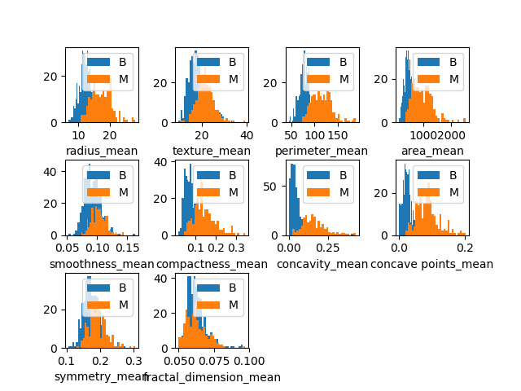

Finished!

Starting Machine Learning Analysis >>> ......

Encoding Label >>> ......

Standardize Data >>> ......

Plotting the test accuracy with the parameter varying >>> ......

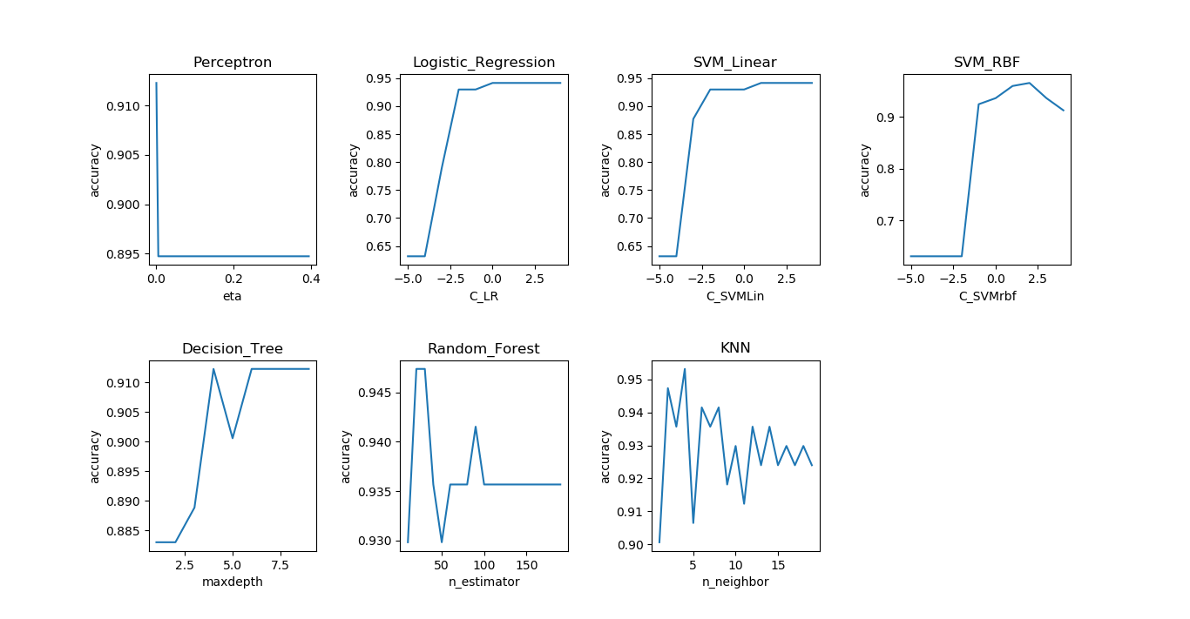

Classifiers involved:Perceptron, Logistic Regression, SVM_Linear, SVM_rbf, Decision Tree, Random Forest, KNN

Plotting the accuracy with the number of features varying >>> ......

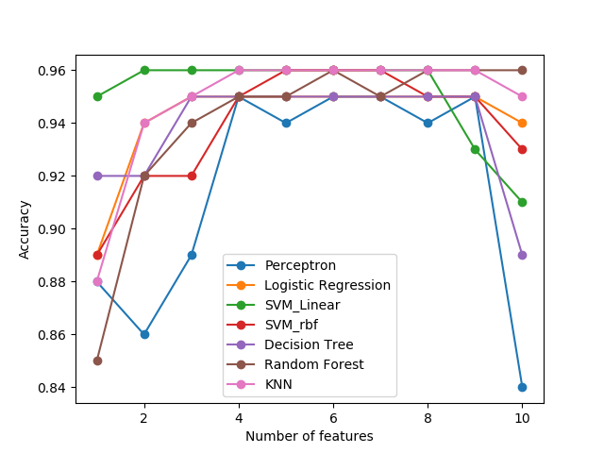

Classifiers involved:Perceptron, Logistic Regression, SVM_Linear, SVM_rbf, Decision Tree, Random Forest, KNN

Feature Importance >>> ......

1) concave points_mean 0.292361

2) concavity_mean 0.177156

3) perimeter_mean 0.143749

4) area_mean 0.115876

5) radius_mean 0.096895

6) texture_mean 0.059167

7) compactness_mean 0.051360

8) smoothness_mean 0.027144

9) symmetry_mean 0.019209

10) fractal_dimension_mean 0.017083

Plotting Learning Curve >>> ......

Classifiers involved:Perceptron, Logistic Regression, SVM_Linear, SVM_rbf, Decision Tree, Random Forest, KNN

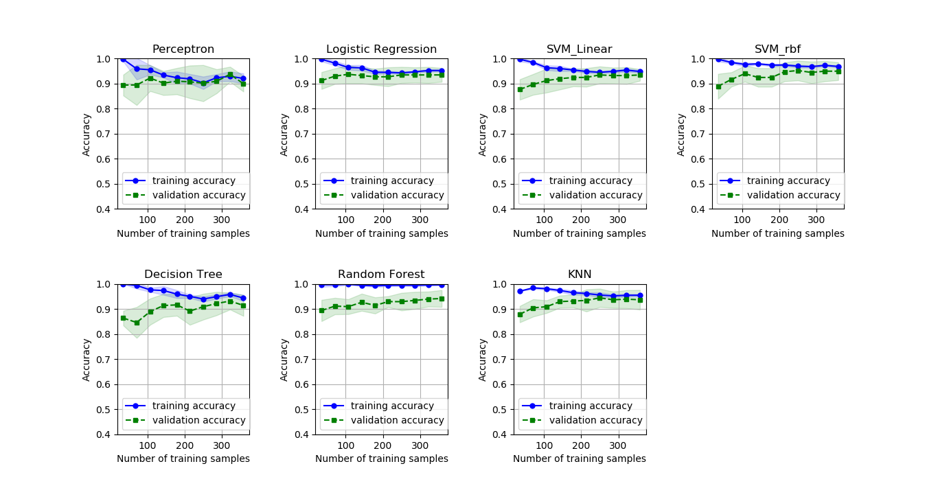

Plotting Learning Curve >>> ......

Classifiers involved:Logistic Regression, SVM_Linear, SVM_rbf

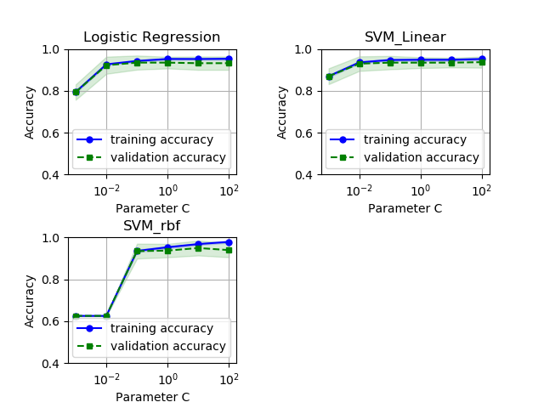

Starting Grid Search Optimization >>> ......

Classifiers involved:SVM_Linear, SVM_rbf

{'clf__C': 100.0, 'clf__gamma': 0.01, 'clf__kernel': 'rbf'}

Finished!